82.06.30
From Janet French
RB MSS M119, Library, Royal Botanic Gardens Melbourne.

A Joyous Birthday.

As round a column tendrils twine
So round a life cling other lives,
May happiness impress on thine
A Birthday light while aught survives!

To Baron Von Mueller
With kindly regards and many happy returns of the day.
Mrs J French.
30/6/82.

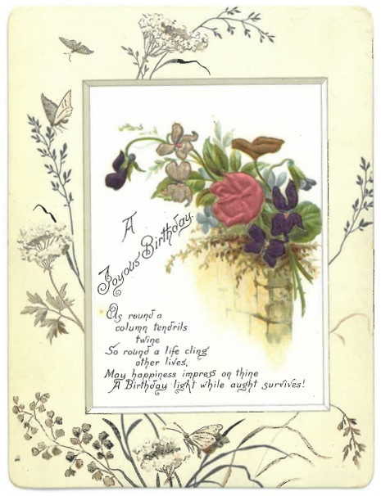

MS is a birthday card, embossed, with images of flowers and butterflies: 82-06-30_image01.jpg The handwritten greeting is on the back of the card. Janet French (née Callander) was the first wife of Charles French and the mother of Charles H. French and George French.

